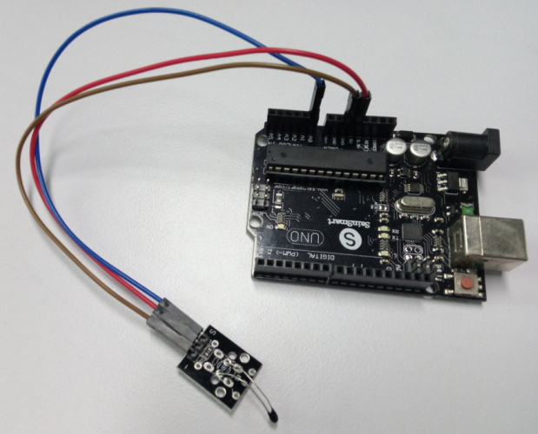

#include <math.h>

double Thermister(int RawADC) {

double Temp;

Temp = log(((10240000/RawADC) - 10000));

Temp = 1 / (0.001129148 + (0.000234125 + (0.0000000876741 \* Temp \* Temp ))\* Temp );

Temp = Temp - 273.15; // Convert Kelvin to Celcius

return Temp;

}

void setup() {

Serial.begin(9600);

}

void loop() {

Serial.print(Thermister(analogRead(0))); // display Fahrenheit

Serial.println("c");

delay(500);

}

